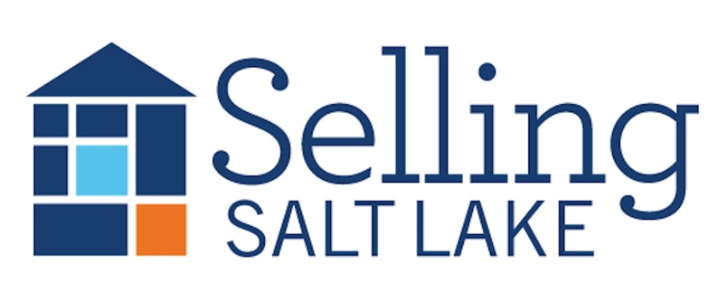
Buyer Agency Best Practices

Before you meet with a client:
1. Review all the language in the Exclusive Buyer Broker Agreement.
2. Review all the information and education and services you provide in the SSL Buying Booklet.
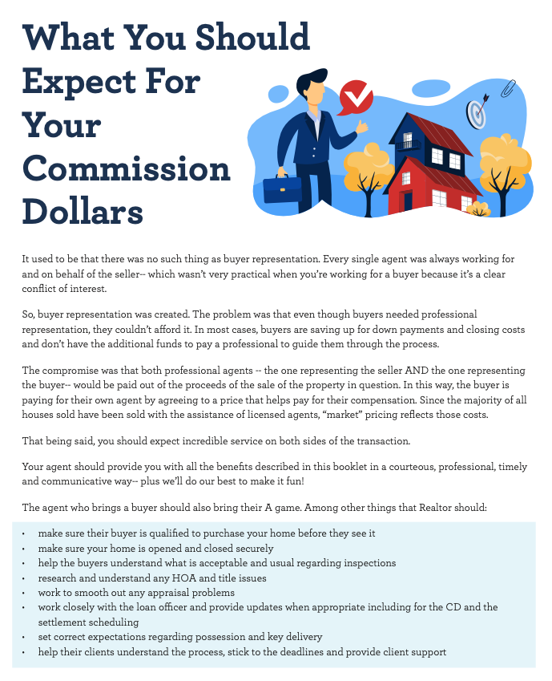
Understand the history!
- NAR founded in 1908
- Buyers had to drive or walk around to see all the listings, or go to all the brokerages to see what houses were available from that office.
- In the 1960’s NAR created the first MLS which was a book with all the listings inside. The binders were distributed once or twice per month. This is the first time commissions started being shared.
- All agents represented the seller as either agents (if the listing was with their office) or sub-agents (if the listing was with a different office).
- A study by the FTC in 1983 showed that 72% of buyers assumed that their agent was working for them.
- Buyer Agency was created in the early 1990s.
--Jack Black Realty
https://www.blackjackrealty.net/blog/how-did-buyer-agency-come-to-be/

Some Language Ideas

Why You Should Hire Me

Chatty:
You Get My Full Attention: By signing on, you're telling me, "Hey, you're the one for the job!" This means all my focus is on finding the perfect place for you. No distractions, just 100% dedication.
Let's Get You the Best Deal: Negotiating can be a bit like a chess game, and I'm here to make all the right moves for you. With this agreement, you're ensuring you've got someone in your corner who knows the game inside out.
Saving You Time and Energy: Your time is precious, and I want to make sure we're using it wisely. With this exclusive deal, we can cut through the noise and focus on the properties that truly match your vibe.
Our Bond of Trust: Transparency is the name of the game. When you sign on, you're not just a client – you're a VIP. Count on me to be completely transparent, always putting your interests first.
I'm pumped about the possibility of us teaming up exclusively to find your dream home.

Professional:
1. Unwavering Dedication: This agreement underscores my commitment to providing you with unparalleled attention throughout the entirety of the home-buying process. Your objectives become my sole focus, ensuring a meticulous search aligned with your unique requirements.
3. Expert Negotiation Tactics: Navigate the intricacies of negotiation with confidence. As your exclusive buyer's agent, I bring forth a wealth of expertise to secure the most favorable terms on your behalf, fostering a seamless transaction.
4. Strategic Time Management: Your time is of paramount importance. With this exclusive arrangement, we streamline the home-buying process, focusing our efforts on properties that align precisely with your criteria, thereby optimizing efficiency.
5. Uncompromising Transparency and Loyalty: Transparency and unwavering loyalty define our professional relationship. The Exclusive Buyer Broker Agreement serves as a testament to our commitment to safeguarding your best interests at every juncture of this journey.
I am enthusiastic about the prospect of representing you exclusively and ensuring the realization of your aspirations in the realm of real estate.

About Commissions

Straightforward:
“I will first go to the listing agent for my commission percentage (and here is where you can find it on the MLS sheet). If you choose to make an offer on a home that offers less than the commission I charge, then this agreement means you will cover the difference.”

Negotiable:
“I charge X. As we discussed earlier, many times I will be paid through the proceeds of the sale—which means that I get paid through the listing agent’s contract with the seller. Each seller and listing agent will negotiate what they are offering to a buyer’s agent like me for each property that is available. You can find out the exact amount by looking at the listing itself on the MLS. If you choose to buy a property where the amount being offered on the listing is more than X, I will refund you the difference at closing as a credit. If the amount being offered on the listing is less than X, you will pay me the difference at closing.

If you choose to Negotiate you will need to amend the EBB with an addendum.
Lawsuits
Moehrl, Sitzer/Burnett, Gibson, Batton 1 and 2, The DOJ
Changes to MLS and COE due to DOJ Investigation 2022
- Display of offer of compensation on public data feeds
- SOP 12-1 – can’t say ‘free’ or ‘no cost’
- Clear cooperation
Where do we go next?
- Set your value and compensation with your clients
- Stop working for whatever the listing brokerage deems appropriate
- Get paid what YOU are worth, not what someone else thinks you should get
- Using EBB gives you control
- Stop thinking buyers won’t sign (in Utah you MUST have an EBB signed)
Explain USP before asking for signatures on EBB
- What makes you stand out?
  - Tailored to your clients and to your market
  - Gives you a competitive advantage
  - Your market distinction expressed as services you offer to your buyers
    - What you do, and how you do it but really WHY do you do it?
- Our session today won’t take long, but it is very important. We’ll be going over what is important to you in your new home, answer your questions about buying, get to know each other a bit and determine if I am the right agent for you
  - Establish if they are working with anyone else
  - Share the buyer presentation
  - Share the new listings, market analysis, days on market, absorption report
  - Prepare a buyer pledge—Because I am committed to you…

The Buyer Compensation Conversation
Will buyers buy without using buyer’s agents? Probably a little bit more.
You have to show buyers the value you bring so they won’t want to work with the listing agents. And—where’s the guarantee they are buying it for less?

Check competition.realtor for infographics

