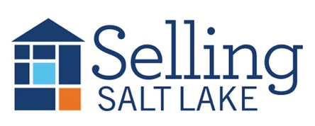
MEETING NOTES July 2, 2025
Keeping in Touch – The Basics
Mail Item of Value * Email * Call/Text * Hand-Written Note * Social Media Snuggle * Pop-By
Pick 3 each month for each contact and watch your business grow!
"A professional is someone who knows what they know, knows what they don't know, and knows the difference between the two."
This distinction is essential, he added. "Nobody knows all the answers. The idea that a professional is someone who knows all the answers — be careful with that one."

DATES TO REMEMBER
7/2 Sales Meeting
7/9 Skills Meeting
7/16 Mastermind/KSL Training
7/23 CE Class Flips, Flops, & Assignments
7/30 5th Wednesday, No Meeting
7/30 Realtor Day at the Parade

Canopy Mortgage Interest Rates
$500k SFR, 20% down, owner occupied, 740 credit score

This Week Last Meeting 6/18/25
Conv 30 YR 6.625 6.875
Conv 15 YR 5.625 5.875
FHA 30 YR 6.125 6.250
VA 30 YR 6.125 6.500
Invest 25% 6.875 6.990

39 Listings
6 Under Contract
7 Buyers Under Contract
84 Closed Transactions

**THIS MEETING WILL BE SUMMARIZED USING AI, AND THE SUMMARY WILL BE EMAILED TO THE BROKERAGE**
- Market Update
- There will be a change to our monthly schedule staring in July as follows:
  - 1st Wednesday Sales Meeting
  - 2nd Wednesday Skills Meeting
  - 3rd Wednesday Mastermind
  - 4th Wednesday CE
  - 5th Wednesday No meeting
- Marketing ideas from First American.
- KSL Classifieds Partnership – we will have the ability to list on KSL starting next week. It will cost $25/listing to post your listings on KSL, this one-time fee will be payable at closing. There will be a training on July 16th.
- MLS Updates.
- Avoid Client Conflicts – attached article
- ListTrac to help set expectations
- Lawrence Yun’s Opinion – attached article
- Compass sues Zillow – attached article
- DRE Newsletter -- attached

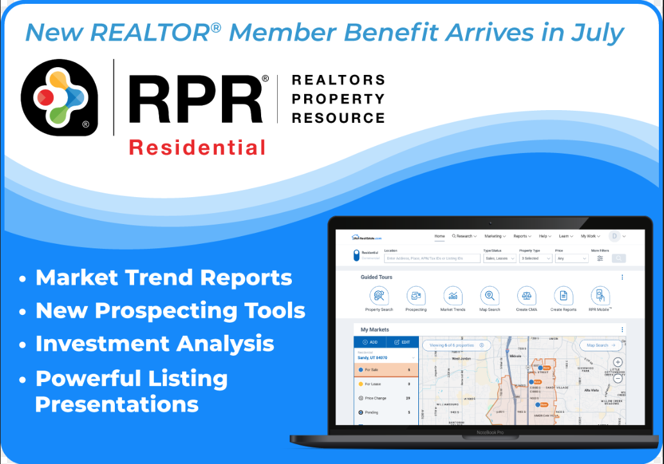

  - Let me know how many tickets you want by July 28th.

