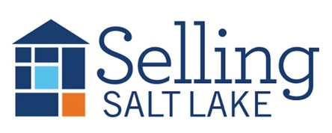
MEETING NOTES June 4, 2025
Keeping in Touch – The Basics
Mail Item of Value * Email * Call/Text * Hand-Written Note * Social Media Snuggle * Pop-By
Pick 3 each month for each contact and watch your business grow!

DATES TO REMEMBER
6/4 Sales Meeting
6/11 Skills Meeting Body – Language
6/18 Sales Meeting
6/19 Daybreak Realtors
6/25 Mandatory CE Class
w/ Curtis Bullock 9-12
7/2 Sales Meeting

Canopy Mortgage Interest Rates
$500k SFR, 20% down, owner occupied, 740 credit score

This Week Last Meeting 5/21/25
Conv 30 YR 6.875 6.875
Conv 15 YR 5.875 6.250
FHA 30 YR 6.250 6.375
VA 30 YR 6.500 6.500
Invest 25% 7.125 6.990

35 Listings
9 Under Contract
14 Buyers Under Contract
68 Closed Transactions

**THIS MEETING WILL BE SUMMARIZED USING AI, AND THE SUMMARY WILL BE EMAILED TO THE BROKERAGE**
- Birthdays and Recognition
- Market Activity and DOM
  - https://www.utahrealestate.com/marketstats
  - 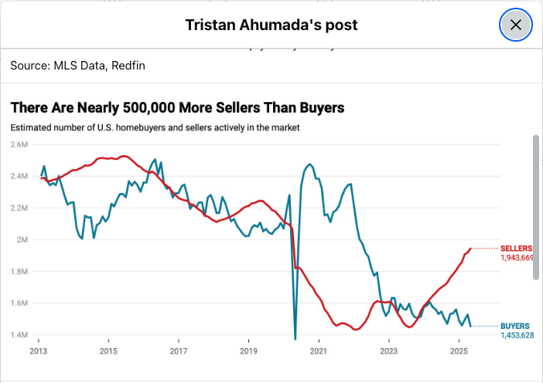
- MLS Updates
- Keybox Buyback from the SLBR
  - If you have more keyboxes than you need, the Salt Lake Board of Realtors® will buy back your used keyboxes! Bring them to the Membership & Education Center, and we will mail you a check for $60 per keybox!

- Fairhaven 2.0 is a new requirement from the NAR that is due every three years along with the Code of Ethics class. This is one 2-hour class.
  - Fairhaven Link
- SoJo Summerfest June 3-June 7—parking lots will be closed on June 7th.
- June Mailers will be stickers – attached for your review. These will be approximately $2.15 per piece. Orders are due by June 9th.

- 
  - Let me know how many tickets you want by July 28th.

SLBR Legal Update


Failure to Disclose & Breach of Contract

SL Realtor® Legal Update - I have several recent failure to disclose, fraud, misrepresentation and breach of contract cases on my desk that have recently been filed here in Utah.

The common argument that continues to be made over and over is that the seller failed to disclose a material defect related to the property. Counsel for the plaintiff buyers are specifically citing misstatements or omissions on the Seller Property Condition Disclosure form that the seller filled out.

This is a simple reminder to stress to your sellers the importance of accurately filling out the Seller Property Condition Disclosure form. Most sellers don't understand why this is so important so be sure to educate and inform them of this critical aspect of selling their property. It protects both you as the listing agent and the seller from potential liability.

- How to cancel a listing/buyer agreement:
--MLS Forms (attached)
--MLS Statuses for Listing Cancelation
https://help.utahrealestate.com/index.php/knowledge-base/listing-input-photos/how-to-guides-listing-input-photos/quick-guide-to-mls-listing-statuses/

Note: Most listing status changes must be made within three (3) business days of the date the status change occurs, with the exception of listings which are Canceled (change within 24 hours) and listings which are Sold (change within 5 business days).

