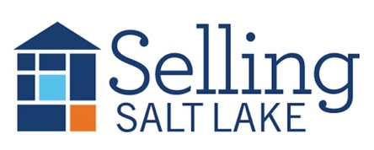
MEETING NOTES March 4, 2026
Keeping in Touch – The Basics
Mail Item of Value * Email * Call/Text * Hand-Written Note * Social Media Snuggle * Pop-By
Pick 3 each month for each contact and watch your business grow!
"A professional is someone who knows what they know, knows what they don't know, and knows the difference between the two."
This distinction is essential, he added. "Nobody knows all the answers. The idea that a professional is someone who knows all the answers — be careful with that one."

Canopy Mortgage Interest Rates
$500k SFR, 20% down, owner occupied, 740 credit score

This Week Last Meeting 2/4/26
Conv 30 YR 6.125 6.125
Conv 15 YR 5.375 5.375
FHA 30 YR 5.750 5.625
VA 30 YR 5.750 5.875
Invest 25% 6.375 6.500
DATES TO REMEMBER
3/ 4 Sales Meeting
3/11 Unconventional Loan Products
3/18 AI Updating Bios and Listings
3/19 Daybreak Realtors
3/25 CE Class
4/1 Sales Meeting
4/8 Skills Meeting

25 Listings
6 Under Contract
11 Buyers Under Contract
14 Closed Transactions

**THIS MEETING WILL BE SUMMARIZED USING AI, AND THE SUMMARY WILL BE EMAILED TO THE BROKERAGE**
https://www.utahrealestate.com/marketstats
- Birthdays and Recognition
- Open House help?
- Info on March mailers coming soon—will probably be a list of friendy pranks for April Fool’s Day.
- 2026 UAR Convention Save the Date – August 31-Sept 2 in Moab
- MLS Updates
- How is going with FinCen so far? Any problems?
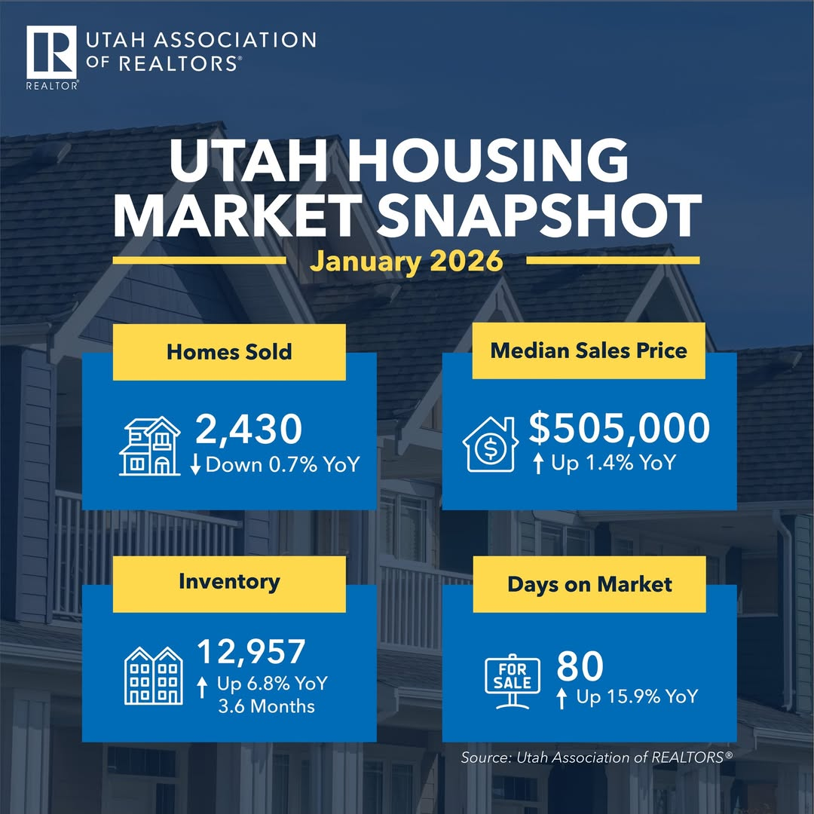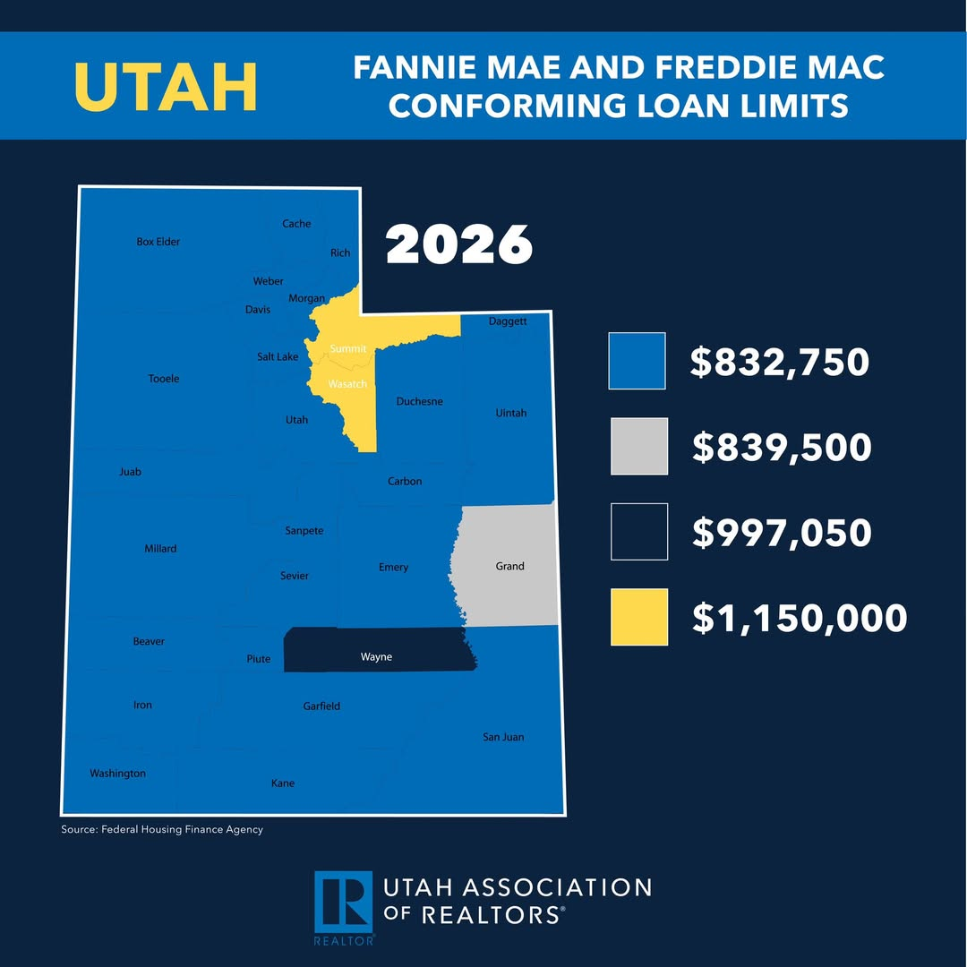

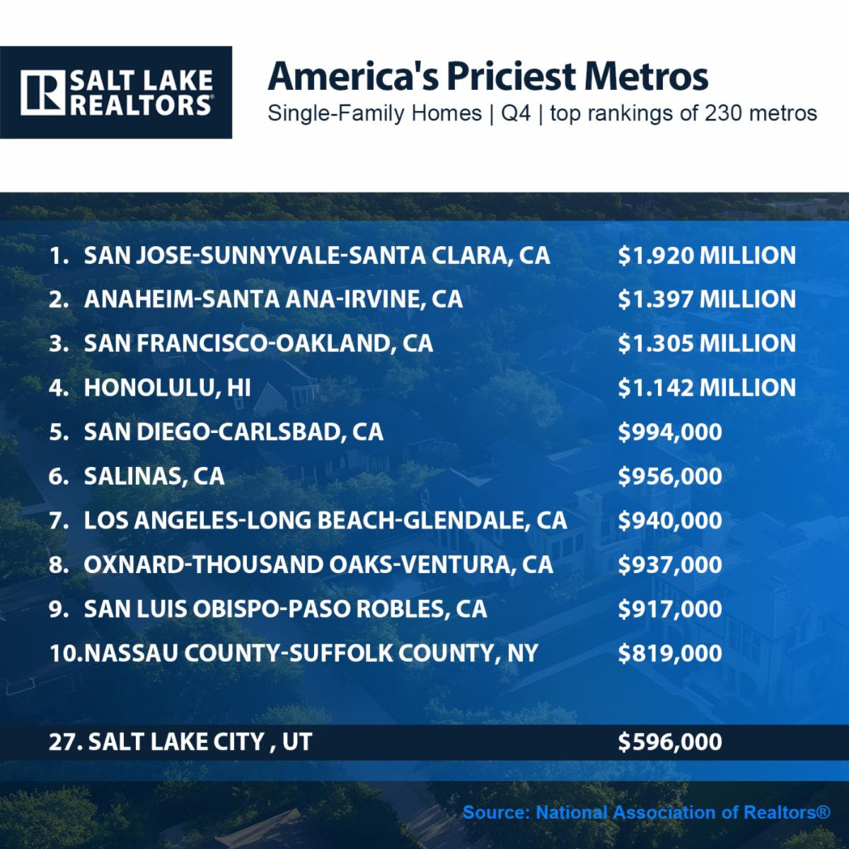

- The Salt Lake City metropolitan area ranked as the 27th most expensive housing market out of 230 metros tracked by the National Association of Realtors®. In the fourth quarter, the median price of a single-family home in the Salt Lake area reached $596,000 — a 5% increase year over year. For comparison, the San Jose metro area had the highest median home price in the nation at $1.92 million. Home prices rose in 73% of metro markets (168 out of 230) during the fourth quarter, down slightly from 77% in the third quarter, signaling a modest cooling in price growth. Nationally, the typical monthly mortgage payment on an existing single-family home with a 20% down payment was $2,057 in the fourth quarter.

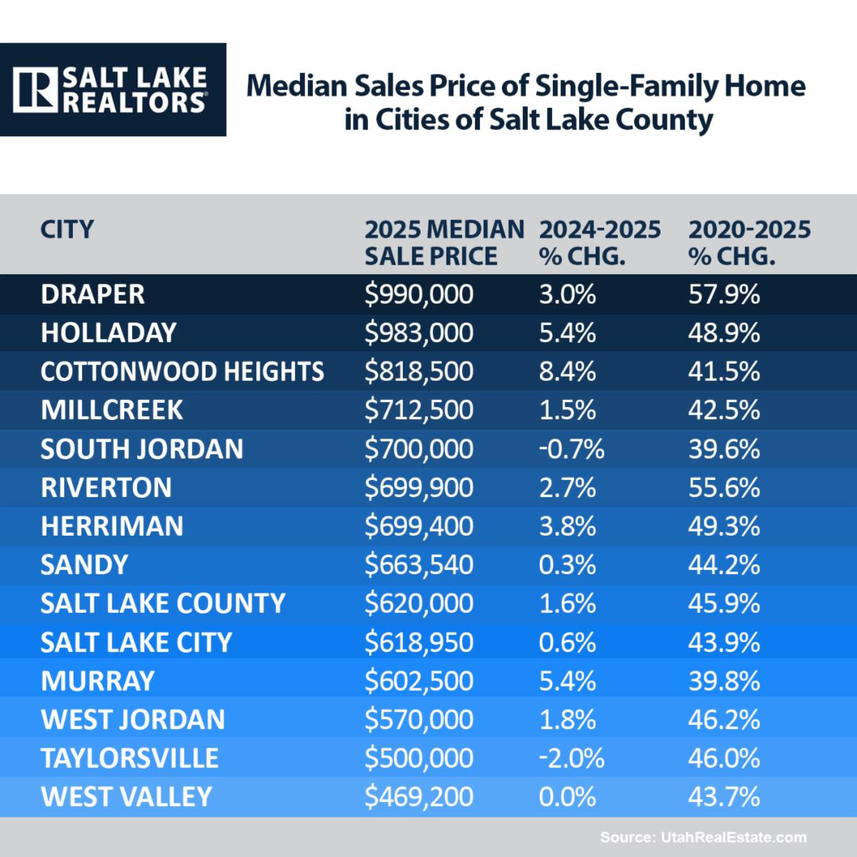

- In 2025, the median sales price for a single-family home in Salt Lake County was $620,000, indicating a market that was stabilizing rather than surging. Draper reported the highest median price among the cities analyzed at $990,000, reflecting a 3% year-over-year increase. Since 2020, Draper’s median price had risen 57.9%, representing the strongest five-year appreciation in the group. Overall, most cities experienced modest year-over-year changes. For buyers, this shift meant improved negotiating conditions, although affordability continued to be influenced by the substantial gains recorded over the previous five years.

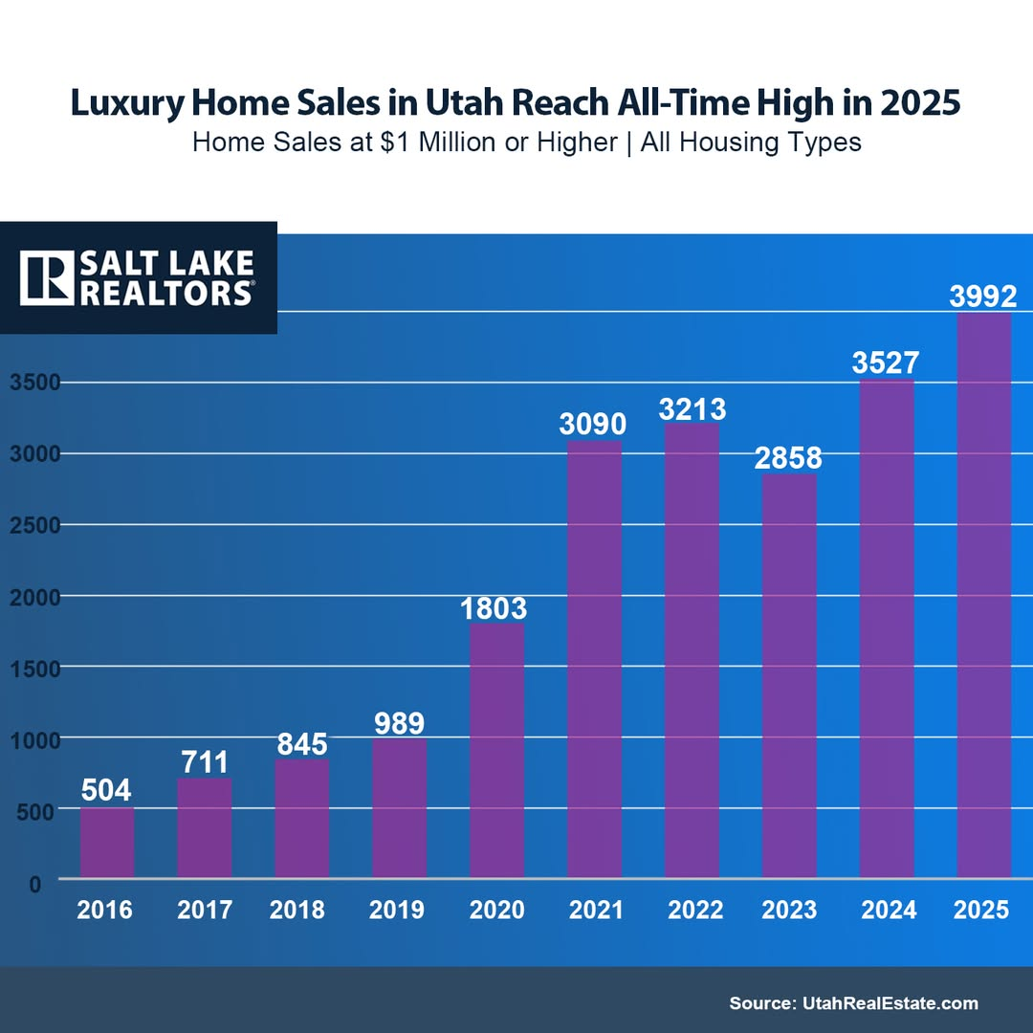

Luxury home sales in Utah hit an all-time high in 2025, with 1 in every 10 homes selling for $1 million or more, according to UtahRealEstate.com. Of the 39,791 homes sold statewide, 3,992 closed at $1 million+, marking a 13% increase over 2024 and a nearly 700% surge compared to a decade ago. Strong appreciation — with home prices up 41% over the past five years — has pushed many properties past the million-dollar mark, while Utah’s strong economy, job growth, and influx of higher-income buyers continue to fuel demand.

Legal Updates from Curtis Bullock:

SL Realtor® Legal Update – Buyer files lawsuit against their own agent for breach of fiduciary duty
A recently filed Utah case serves as an important reminder of the responsibilities buyer agents owe to their clients.
Allegations in the complaint: The buyer hired an agent to help locate a home. The buyer made it clear that their most important requirement was the ability to construct a detached shop in the backyard. The agent located a property, and the buyer went under contract and eventually closed—believing they would be able to build the shop and that their agent understood and had addressed this issue.
Shortly after closing, the buyer discovered an easement on the property that prevented construction of the shop. Feeling misled, the buyer consulted an attorney and filed suit against their own agent and brokerage.
The complaint includes the following allegations:
- The buyer agent provided the Buyer Due Diligence Checklist after the Due Diligence Deadline had already expired, which the attorney argues was a breach of fiduciary duty.
- The agent “bundled” the Exclusive Buyer Broker Agreement and the REPC into a single PDF document and had them signed together. The buyer’s attorney argued that these are separate agreements and should have been presented and signed independently.
- The agent failed to provide the buyer with and review the title commitment, which would have revealed the backyard easement preventing construction of the shop.
- As a result, the buyer alleges the agent acted negligently and breached their fiduciary duties, seeking nearly $200,000 in compensatory and punitive damages.
Key Takeaways for REALTORS®:
- Keep agency agreements separate from the REPC. Do not combine them into one document or present them as a package.
- Provide the Buyer Due Diligence Checklist—and all other required documents—on time. Timeliness matters.
- Do not overlook the title commitment. Review it carefully, provide it to your client promptly, and advise them to thoroughly review it and ask the title company or an attorney questions about any concerns.

SL Realtor® Legal Tip - Basic contract law.

This question came up again the other day.

Suppose you send in an offer for your Buyer. The time for acceptance expires and the Seller does not accept it. A day or two goes by and the Seller changes their mind and decides to accept with one minor point that will be included in the counter. When the Seller's Agent calls the Buyer's Agent, the Buyer's Agent is adamant in saying, "great, just be sure to extend the Acceptance deadline in your counter offer so we are legal."

Is this necessary? If so, why? If not, why not?

ANSWER: No, it is not necessary. The counter offer revives the expired offer and creates a new Acceptance deadline.

SL Realtor® Legal update - DIY remodel resulting in major repairs

I have another Utah lawsuit on my desk involving failure of the seller to disclose mold, improper plumbing, damaged sub flooring, improperly installed HVAC pipes, etc all done by a DIY home renovation. No permits were obtained by the seller / DIY'er resulting in defective work amounting to $150,000 in damages. The buyer filed a lawsuit against the seller for breach of contract, negligence and fraud.

Key takeaways -
1. Verify permits on remodeled properties
If you represent a buyer interested in a "recently remodeled home," specifically ask whether all required permits were obtained. I routinely see disputes when sellers don't get the necessary permits to save time or money.
2. Identify who performed the work
Buyers should determine whether licensed contractors completed the renovations. If work was performed by the seller or unlicensed individuals, additional scrutiny and inspections may be needed.
3. Use the due diligence period wisely
Encourage buyers to spend additional time during the inspection to make sure the condition of the home is acceptable.
4. Confirm contractors have been paid
Buyers should verify that all contractors were fully paid to reduce the risk of a mechanics lien being recorded after closing.
5. Listing agents: emphasize full disclosure
Listing agents should ensure sellers disclose all material facts relating to the remodel, including permits, contractors used, and known defects even if the seller has not occupied the property. Be sure the seller understands that even though the property is sold "as-is," that has nothing to do with disclosure law.

