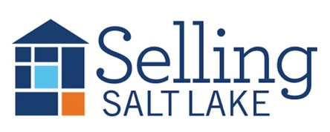
MEETING NOTES April 1, 2026
Keeping in Touch – The Basics
Mail Item of Value * Email * Call/Text * Hand-Written Note * Social Media Snuggle * Pop-By
Pick 3 each month for each contact and watch your business grow!
"A professional is someone who knows what they know, knows what they don't know, and knows the difference between the two."
This distinction is essential, he added. "Nobody knows all the answers. The idea that a professional is someone who knows all the answers — be careful with that one."

Canopy Mortgage Interest Rates
$500k SFR, 20% down, owner occupied, 740 credit score

This Week Last Meeting 2/4/26
Conv 30 YR 6.500 6.125
Conv 15 YR 5.625 5.375
FHA 30 YR 5.990 5.750
VA 30 YR 6.125 5.750
Invest 25% 6.625 6.375
DATES TO REMEMBER
4/1 Sales Meeting
4/8 Skills Meeting
4/15 Mastermind
4/16 Daybreak Realtors
4/22 CE Class
4/29 5th Wednesday, No Meeting
5/6 Skills Meeting

25 Listings
4 Under Contract
12 Buyers Under Contract
34 Closed Transactions

**THIS MEETING WILL BE SUMMARIZED USING AI, AND THE SUMMARY WILL BE EMAILED TO THE BROKERAGE**
https://www.utahrealestate.com/marketstats
- Birthdays and Recognition
- Open House help?
- New “Getting Ready To List” Timeline
- MLS Updates
- The Drama, the Intrigue, the Status of FinCen!
On March 19, 2026, a federal district court in Texas vacated the Financial Crimes Enforcement Network's (FinCEN) Residential Real Estate Anti-Money Laundering (AML) Rule, holding that the agency exceeded its statutory authority under the Bank Secrecy Act (BSA) and violated the Administrative Procedure Act (APA). As a result, the rule has been set aside. FinCEN posted a statement noting, “In light of a federal court decision, reporting persons are not currently required to file real estate reports with FinCEN and are not subject to liability if they fail to do so while the order remains in force.”
Neither the Department of Justice (DOJ) nor FinCEN has yet indicated whether there is a plan to appeal the ruling. DOJ may also seek a stay of the decision if they choose to appeal, which could reinstate compliance obligations until an appellate court rules.
- New SPCD

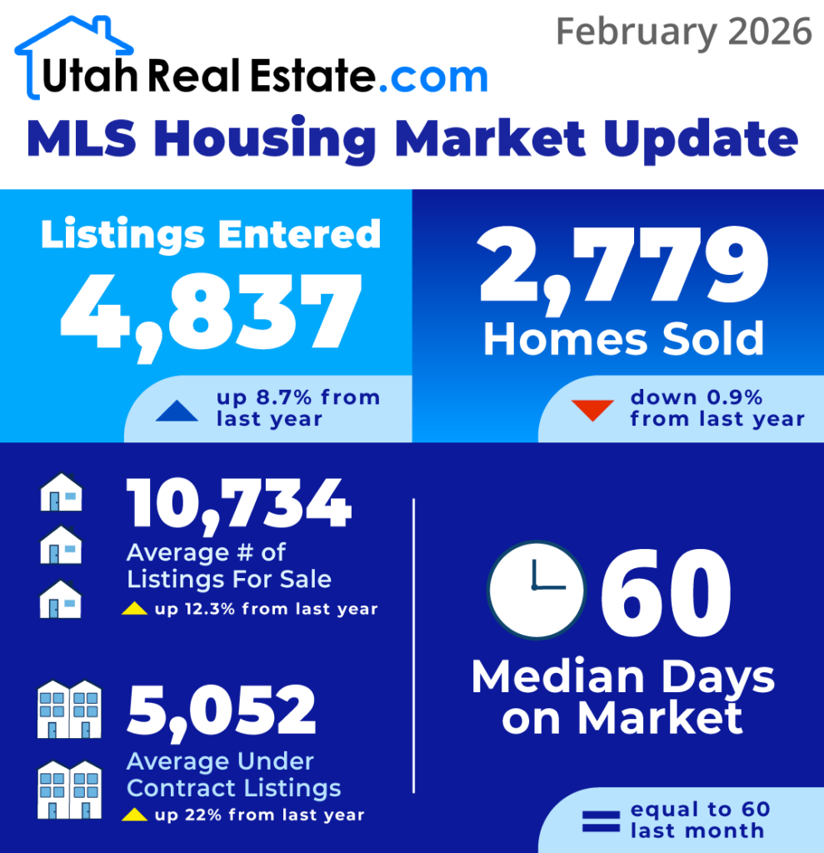

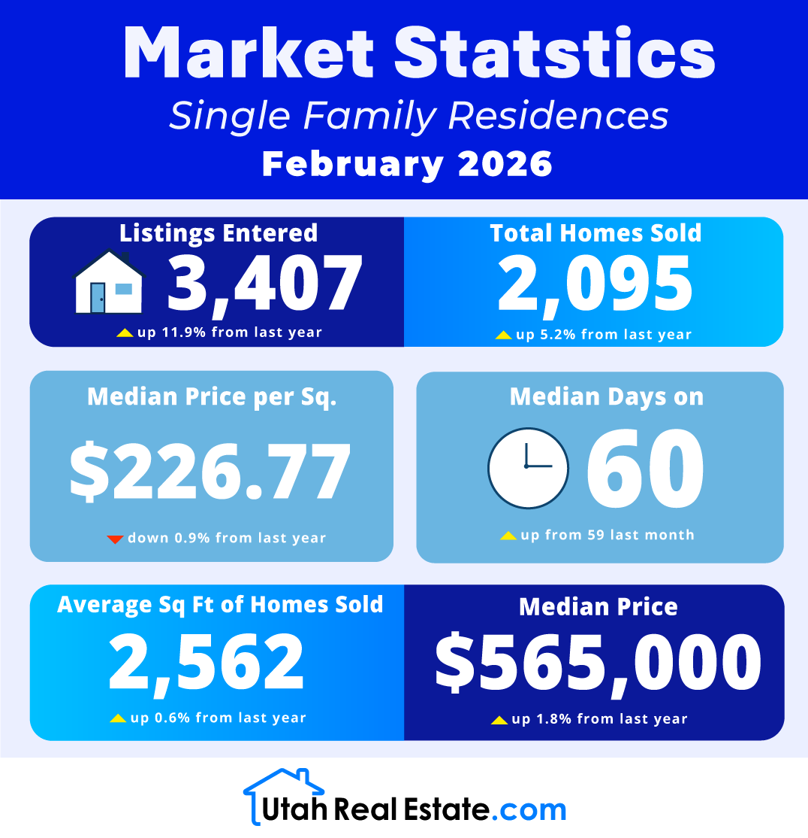
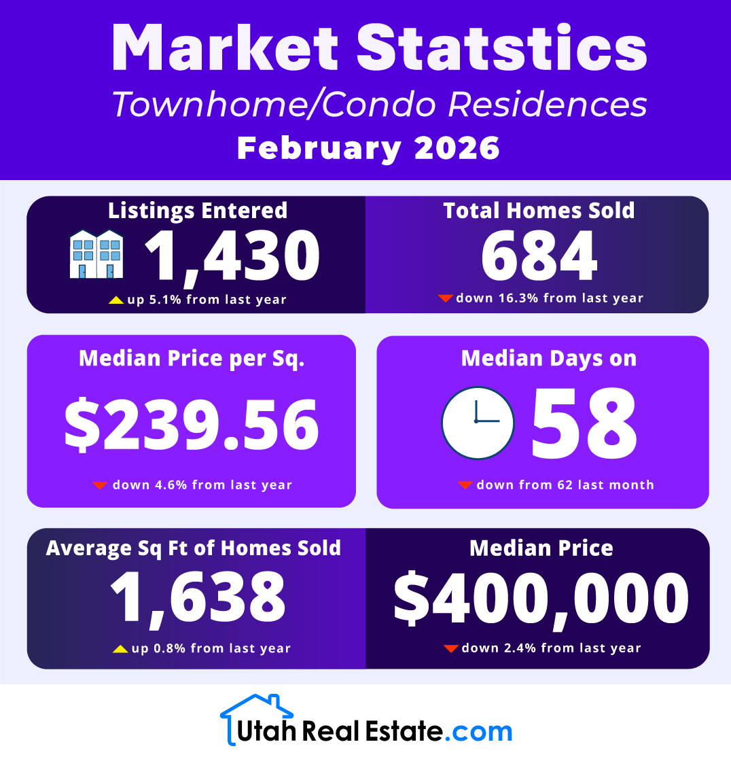

Fraud Alerts:

After a couple of quieter months, scam activity appears to be picking up again. We received several reports this past week, making this a good time to catch up on the latest tactics showing up on both the seller and buyer sides of transactions.

Michael Kermizis at Engel & Volkers reported one “Gregory Fox” wanting to list his vacant lot at 2270 River Meadows Parkway, Midway. “Greg’s” inquiry originated from 561-875-2301 and used the email address gregryfox97@hotmail.com. We had a nice chat with the real Mr. Fox through a phone number we found in Forewarn, another PCMLS service, and confirmed he is not shopping for an agent. Mr. Fox also said he used AI to confirm my identity before returning the call. Smart fellow. Thanks, Michael.
Gabe Westberg at Windermere received a call from “Randy Huntress,” using a Charleston, South Carolina phone number, (843) 330-1711. He said he was in a big hurry to sell his land in Pine Meadow Ranch, 2185 Uintah View Dr., Coalville, UT 84017, due to medical reasons. As we have noted before, “medical problems” are the number one excuse scammers use to justify a fast sale at a low-ball price. Gabe reports that the real Randy is an escrow officer in Texas with a 214 area code. Oopsie, Mr. Scammer. You picked on the wrong fellow.
Multiple sources, Casey Jones at Real Estate Essentials, Angela Faber at Realty One Group, and Kathy Vallee at Sotheby’s, ganged up on “Kirkpatrick McDonald,” who was attempting to sell 686 W Deer Hill Rd., Park City, UT 84098, while calling from 323-207-1824. This one was confirmed as fraud when the personal assistant to the real Mr. McDonald contacted Summit County Assessor Stephanie Paice to report another inquiry from yet another agent. Stephanie forwarded the assistant’s contact information to us and filed a report with the Summit County Sheriff’s Office.

Our fraudulent friends do not just work the seller side of the deal. Our agents also receive suspicious buyer inquiries.

Wayne Levinson at Keller Williams turned down an inquiry, with no name attached, coming from 804-434-8558, from someone who wanted to connect on Zoom.

Chris Simons at Sotheby's is a magnet for bogus inquiries. Ely Urbina, elyurbina733@gmail.com, and her husband want to buy something in Salt Lake City and, of course, want to coordinate with us and our lawyer via Zoom throughout the process. Chris ignored that message, then received a follow-up three days later. Persistence.

She also received a seller request through Realtor.com from Albert Galik, 310-427-4312 and AlbertGalik236@outlook.com, who did not even mention the address of the property. The real Albert Galik lives in Houston and has a 713 area code.

Chris hit the trifecta with another RDC inquiry from Staker Ken, Stakerken101@outlook.com. Our agents know the scammer is lazy when they cannot even be bothered to flip the first and last name they pulled from county records. But this fellow was so lazy he simply copied and pasted Albert Galik’s message and used the same bogus phone number.

- Article: Pre – Listing Wars
- Article: Economic Unease Threatens Early Year Housing Market Momentum
- Ethics Complaint: Names have been changed.
  - Ethics Complaint: This issue came to my attention when our agent emailed me on February 9th. Our agent signed a buyer representation agreement January 11th with the buyers: Sally and Tommy Buyers. After that, the buyer's cousin, Cousin Amy called our agent First Agent Sam asking for a referral, when First Agent Sam declined the agent said that her cousins would cancel their agreement and she would refer them to someone who would give her a referral fee. Two days later the buyers reached out to First Agent Sam asking to cancel their agreement stating they wanted to work with another realtor and wouldn't give any reasons as to First Agent Sam not fulfilling their needs. The issue is Cousin Amy interfered with First Agent Sam's Buyer Representation agreement, She cannot tell her cousins to cancel or stop working with an agent they are in contract with. Our agent let them out of their contract because they asked to not work together anymore and when First Agent Sam met with them initially she said that if things don't work out that she would do the right thing and they could end their agreement, as they wished, so that's what they did. Thank you, Broker for First Agent Sam
  - TEXT CHAIN:
  - Hi Cousin Amy, it was great to talk with you! I have been working with this buyer since the beginning of December and she didn't bring you up since I started talking to her. We do have a signed BAA from early January. I just spoke with my team leader and she confirmed that it is too late to add a referral component to the agreement. I am so sorry, but I hope you understand. I would love to keep you as a contact though to refer any clients to. I used to live in Utah, which part are you in?
  - That's too bad, First Agent Sam. I've been working with my cousins for the last year to get her in this position to buy.
  - I can check with my broker, if you would like. I am sorry, I have had family do that to me too honestly.
  - I spoke to her after talking to you. I'm happy to have to cancel and refer her over to someone in my brokerage if that's the case. I hope you understand. Can you resend her the BAA?
  - It is up to the buyer and I to cancel our agreement. I am sorry that this frustrates you, but if you have any questions, I can provide you with my team leaders and brokers contract who can explain it.
  - It is a bit frustrating. This is more ethics than it is timing. They were unaware of how our business works and were excited to see a home. Sure, that would be perfect. If you can send me their contact info. Can you also resend over the agreement (BAA) to the buyer. I never received it from you.

NAR Code Of Ethics

