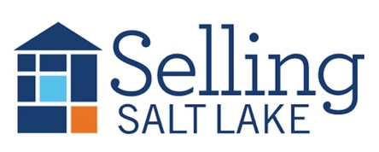
MEETING NOTES June 18, 2025
Keeping in Touch – The Basics
Mail Item of Value * Email * Call/Text * Hand-Written Note * Social Media Snuggle * Pop-By
Pick 3 each month for each contact and watch your business grow!
"A professional is someone who knows what they know, knows what they don't know, and knows the difference between the two."
This distinction is essential, he added. "Nobody knows all the answers. The idea that a professional is someone who knows all the answers — be careful with that one."

DATES TO REMEMBER
6/18 Sales Meeting
6/19 Daybreak Realtors
6/25 Mandatory CE Class
w/ Curtis Bullock 9-12
7/2 Sales Meeting
7/9 Skills Meeting
7/16 Sales Meeting

Canopy Mortgage Interest Rates
$500k SFR, 20% down, owner occupied, 740 credit score

This Week Last Meeting 6/4/25
Conv 30 YR 6.875 6.875
Conv 15 YR 5.875 5.875
FHA 30 YR 6.250 6.250
VA 30 YR 6.500 6.500
Invest 25% 6.990 7.125

39 Listings
8 Under Contract
14 Buyers Under Contract
76 Closed Transactions

**THIS MEETING WILL BE SUMMARIZED USING AI, AND THE SUMMARY WILL BE EMAILED TO THE BROKERAGE**
- Market Update
- Description of Grievance Committee, Professional Standards and recent case regarding wholesaling.
- We should have all the mailer supplies for the sticker campaign ready for you by Friday the 20th. Please have your assembled mailers back by Wednesday, June 25th
- Updated Code of Ethics is coming soon. These changes have been made as of 6/25/25.
  - The new language, which you can review here, 1) creates a more specific definition of “harassment,” aligning with the definition in the NAR Member Code of Conduct, and 2) focuses Article 10’s—along with the entire Code of Ethics’—application on instances in which REALTORS® are operating in their professional capacity, consistent with similar ethical requirements applied by other large trade associations across the country. Further, by enhancing the clarity of this language, the changes reduce risk to state and local associations and their volunteer leadership who administer and enforce Article 10.
  - New Article 10-5 REALTORS®, in their capacity as real estate professionals, in association with their real estate businesses, or in their real estate-related activities shall not harass any person or persons based on race, color, religion, sex, disability, familial status, national origin, sexual orientation, or gender identity.

As used in this Code of Ethics, harassment is unwelcome behavior directed at an individual or group based on one or more of the above protected characteristics where the purpose or effect of the behavior is to create a hostile, abusive, or intimidating environment which adversely affects their ability to access equal professional services or employment opportunity. (Adopted and effective November 13, 2020, Amended 1/23 and 6/25)

- Unrepresented Buyers
  - What to expect going forward
    - August 17, 2024 – June 17, 2025
      - 3516 MLS-NON Sold listings
      - 31,307 total Sold listings
      - 11%
    - August 17, 2023 – June 17, 2024
      - 2858 MLS-NON Sold listings
      - 29,810 total Sold listings
      - 9.5%
  - Limited Agency
  - On the ERS
  - Unrepresented Buyer Disclosure
- REAL - Tours
- Join a Tour!

RealTours is shifting gears to the caravan model! Tours will alternate from East to West, and caravans will be organized based on location. Click the button above to learn more!


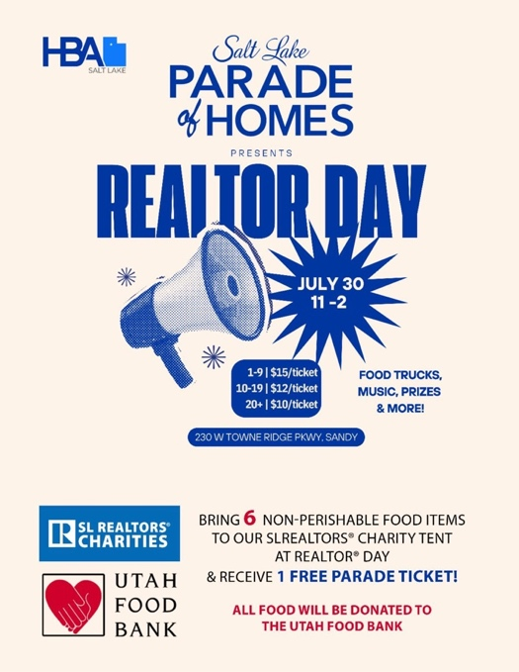
  - Let me know how many tickets you want by July 28th.
